Q1

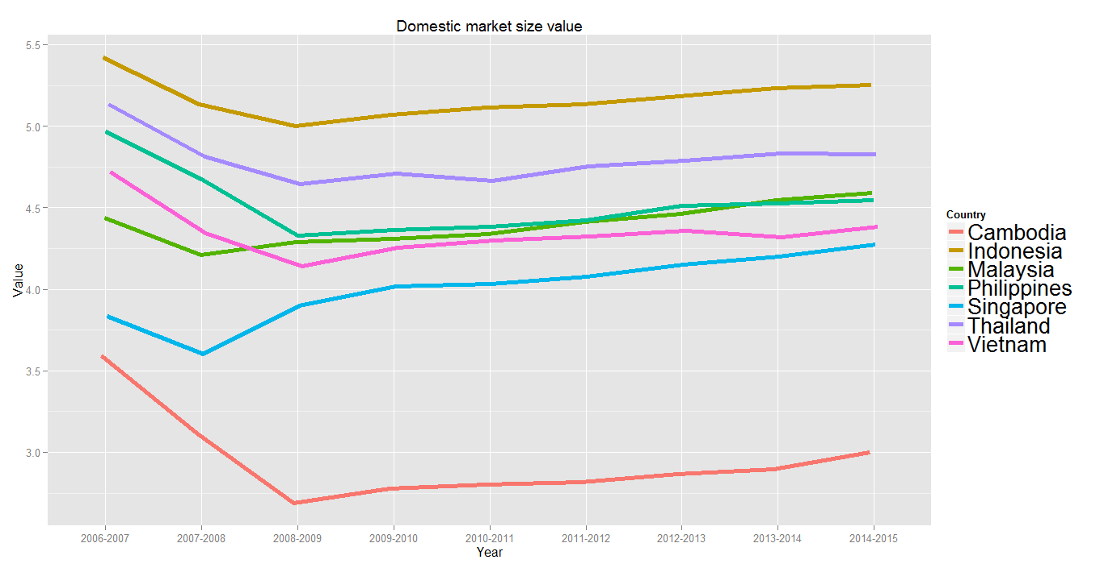

The domestic market for all of the country show a decline in value from year 2007-2009, which indicated that the global economy is having a downfall during this period, but Malaysia and Singapore market start to bounce back on 2008.

As for the Rank in the domestic market, most country are stable in the ranking although they have dropped in market value, but due to it is a global economy crisis thus the ranking does not affect much,

As for Malaysia and Singapore, they manage to bounce back from the economy downfall, they manage to rise in their ranking. As of Cambodia, due to their dramatic decrease in the market value, it affected their ranking.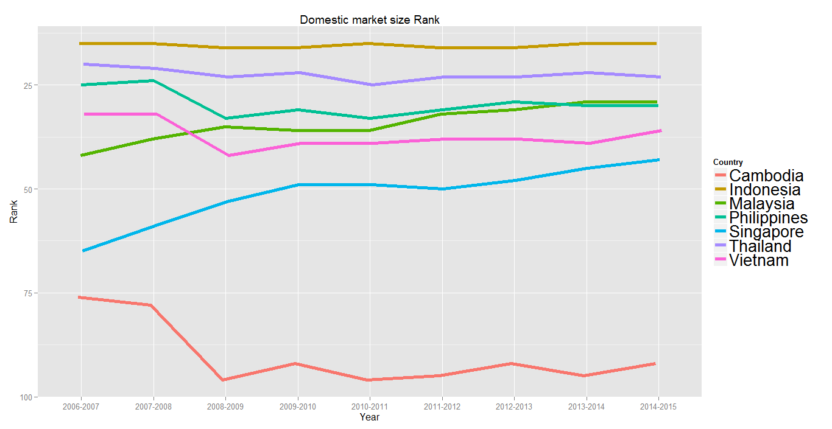

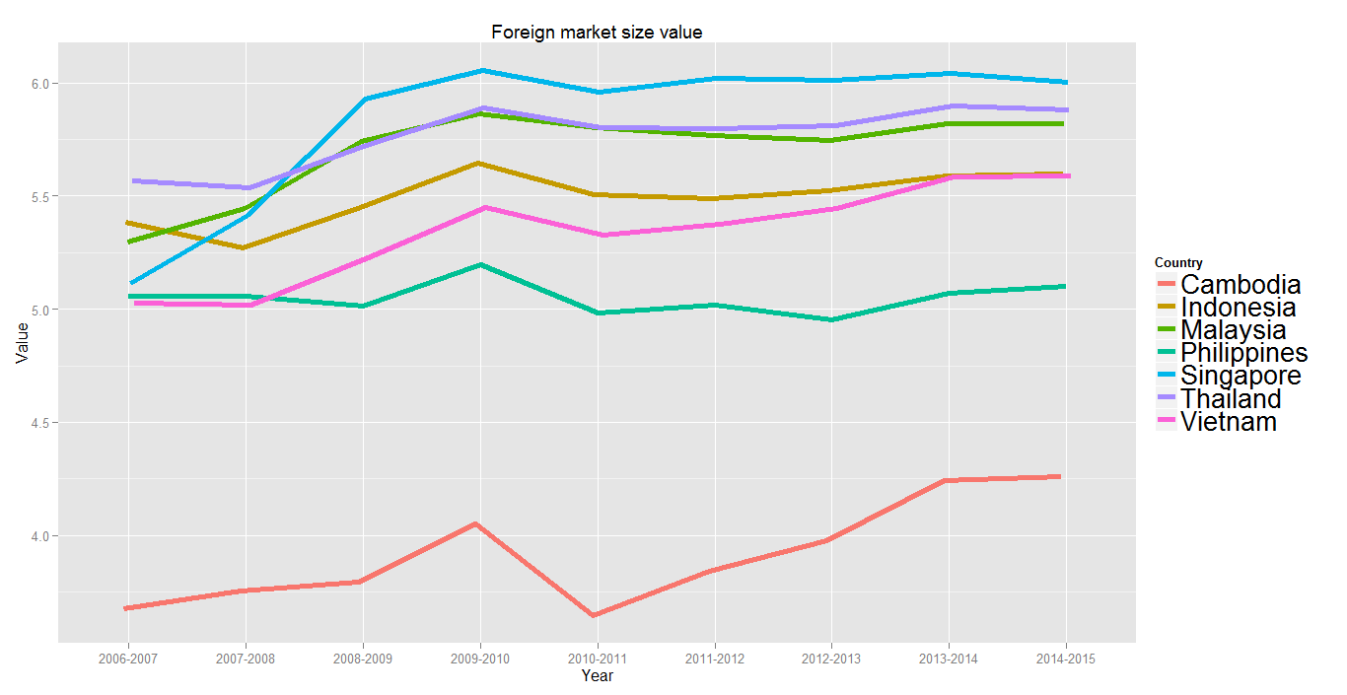

As for foreign market size, most country have rised in foreign market size value, which indicate that the global economy is doing fine. On 2010, all country is have a downfall in foreign market size value. Dispite the downfall, most country is stable in their ranking which indicates that it maybe the affecting globally.

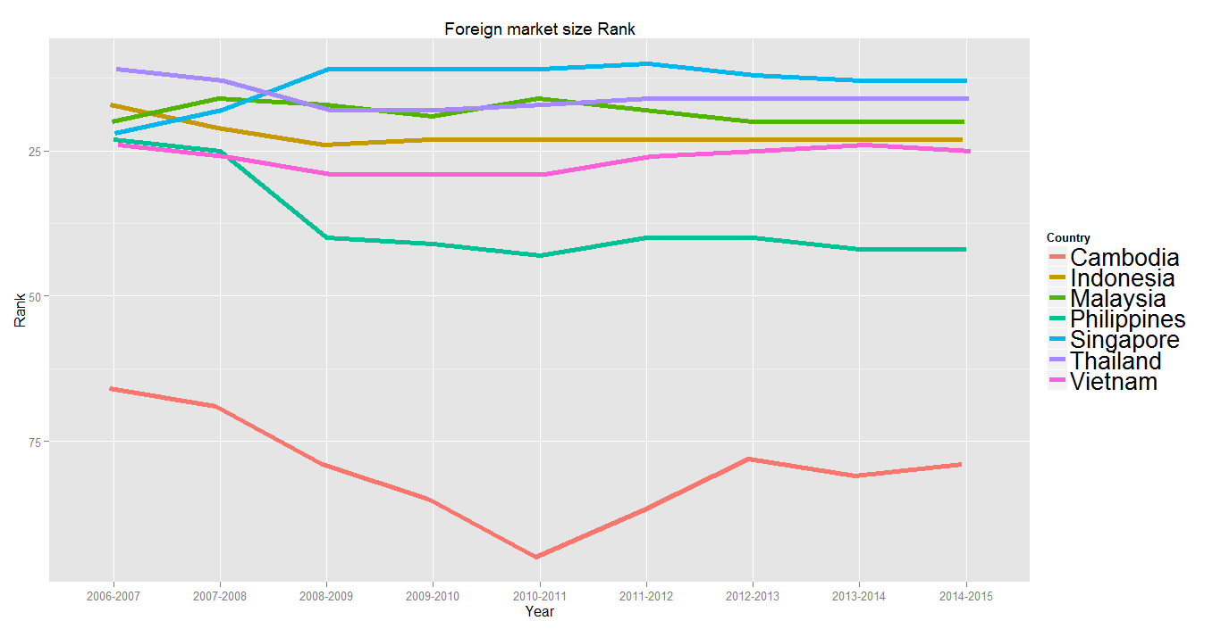

Q2

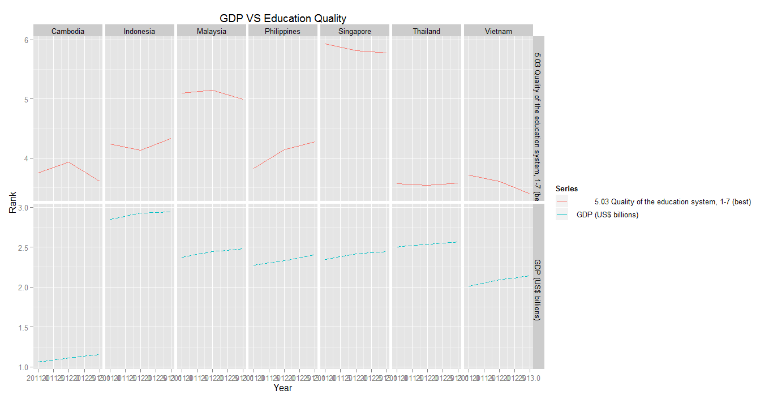

The above graph shows the comparison between GDP value and the Quality of Education system for each country between year of 2011 to year of2013. It is only subset of the whole data set, the period where there is a big drop, causing the data to fluctuate down was removed, those data could cause the reading to be inaccurate due to those data was likely caused by the global economy downfall, which is not related to education.

From this we graph it shows that the for all the country shown is having an increase in the quality of the education system, yet not every country’s GDP value follows.

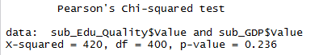We further perform chi-square test on both terms and the P-value was 0.236, which indicate that these two terms are no effect on each other.

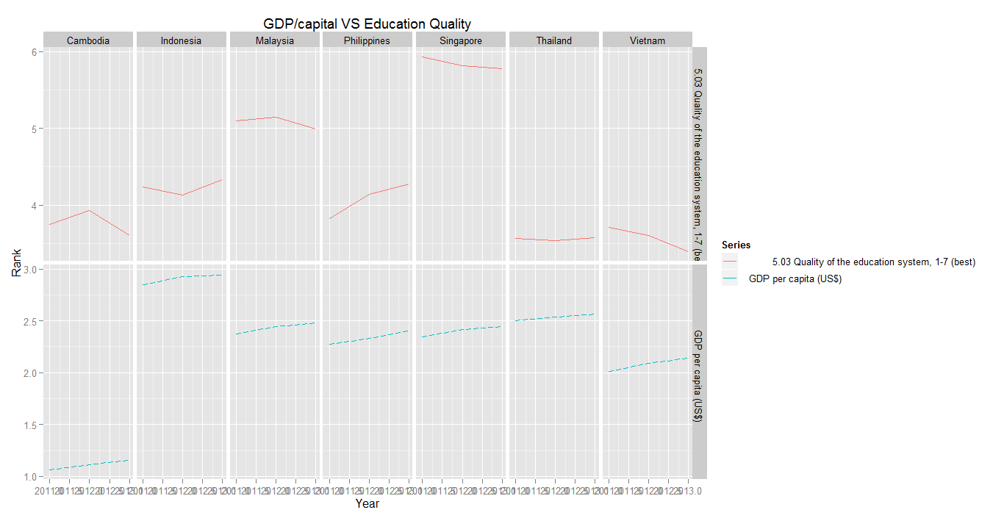

Q3

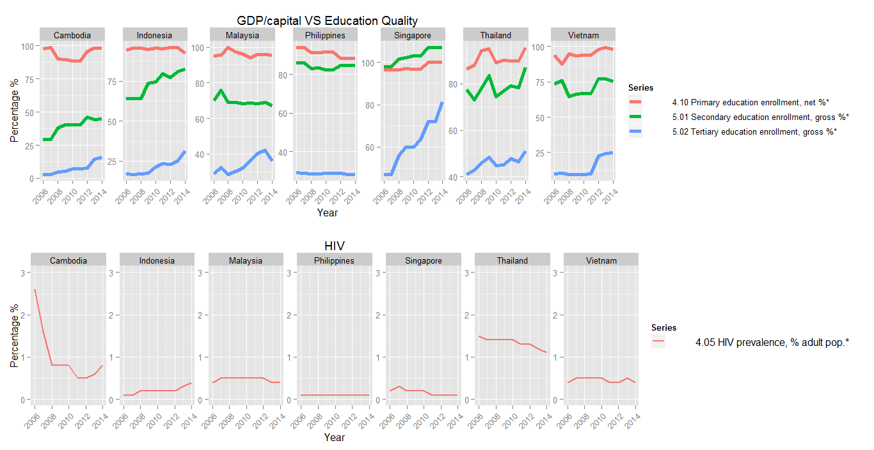

There is a general trend that the education Quality is improving for all the country except for Philippines, and also there is a general trend that the HIV prevalence is decreasing over the year, with certain spikes.

Q4

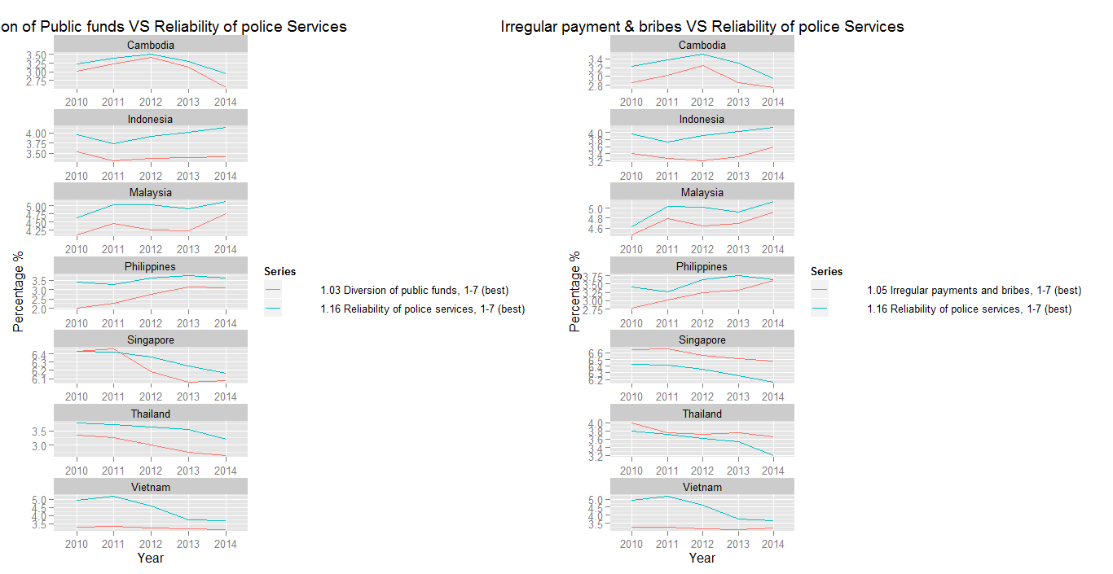

As shown in the graph, there seems to have a positive correlation between both “Diversion of public fund” and “Irregular payment and bribes” to the “Reliability of police service” for almost all the countries except Vietnam.

Based on common understanding, Diversion of public funds, irregular payment and bribes may contribute to corruption, and corruption should not result in the reliability of the police services. There could have a unknown term that is in-between this Reliability of police service and the other which is affecting the reliability of police service and of which is affected by the other terms.

Q5

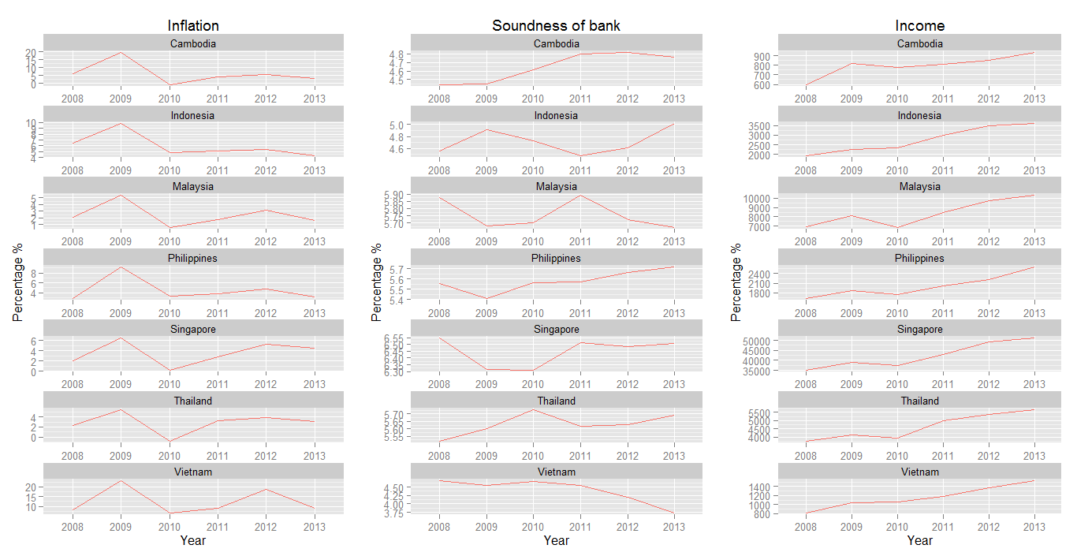

Based on the graph, there seems to have little or no relationship between the Income to the Inflation and the Soundness of the bank.

Then at a closer look between Inflation and Income, there is a following pattern. At year 2010, there is a huge drop decrease in inflation for all country, and then the income for most country allow affected in the gradient of the constant growing trend for Income.